Python Basics and Programming Concepts: Unit 1 Study Guide

Unit overview
Part | Syllabus topics | Why data science needs it
1. Introducing Python | History, features, how code executes | Know where and how your analysis scripts run
2. Types and Operations | Numbers, strings, lists, tuples, dictionaries, files, dynamic typing | Every dataset is held in these structures
3. Statements and Syntax | Assignments, expressions, loops, iterations, comprehensions | Clean and transform records in a few lines
4. Functions | Basics, scopes, arguments, advanced functions | Package analysis steps so they can be reused
5. Modules | Module coding basics, packages, advanced module topics | NumPy and pandas are modules and packages you import
6. Classes and OOP | Classes, operator overloading, class designing | A DataFrame is a class; operators such as + and [] are overloaded
7. Exceptions and Tools | Exception basics, coding details, exception objects, design, parallel system tools | Scripts that survive bad data and use every CPU core
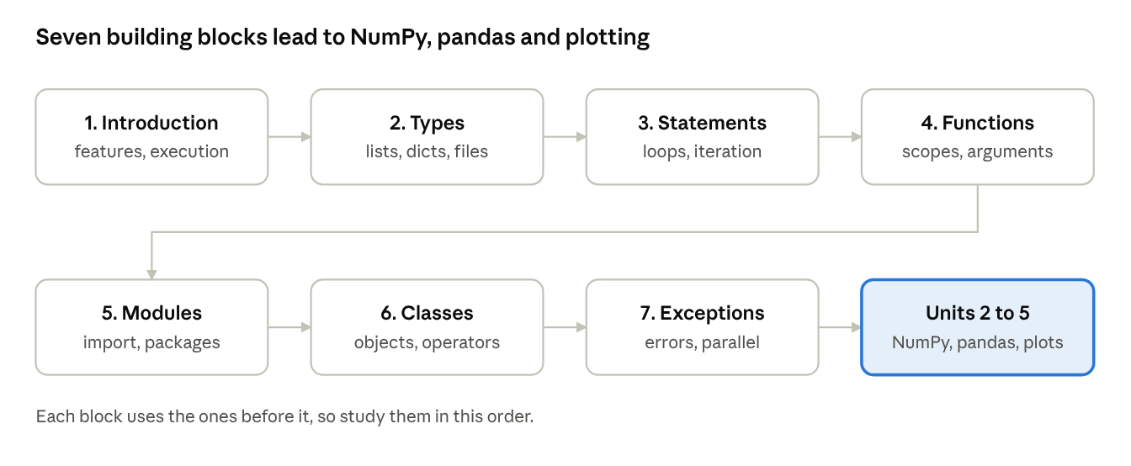
unit roadmap · 7 blocks
The roadmap follows the syllabus order: the first four blocks cover the language itself, and the last three cover how code is organized, modelled and protected from errors.

1. Introducing Python
Python is a high-level, interpreted, general-purpose language created by Guido van Rossum and first released in 1991; it dominates data science because it reads almost like English and has a vast library ecosystem.

1.1 Key features
- High-level: you work with lists, strings and dictionaries directly, without managing memory.
- Interpreted: code runs statement by statement, so you can test ideas instantly in the interactive prompt or a notebook.
- Dynamically typed: you never declare variable types; the object carries its type.
- Multi-paradigm: supports procedural, object-oriented and functional styles in one program.
- Open source and portable: the same script runs on Windows, Linux and macOS.
- Batteries included: the standard library covers files, maths, dates, networking, JSON and CSV.

1.2 Why Python for data science
- A rich toolkit: NumPy (arrays), pandas (tables), matplotlib (charts) and scikit-learn (machine learning).
- Short, readable code, so analysts spend time on the problem rather than the syntax.
- Interactive workflows through the REPL and Jupyter notebooks.
- A very large community, so most problems already have a documented answer.

1.3 How Python runs a program
The standard implementation, CPython, first compiles your source file to bytecode, then the Python Virtual Machine (PVM) executes that bytecode one instruction at a time. The compiled bytecode is cached as .pyc files inside a __pycache__ folder so unchanged modules load faster next time.
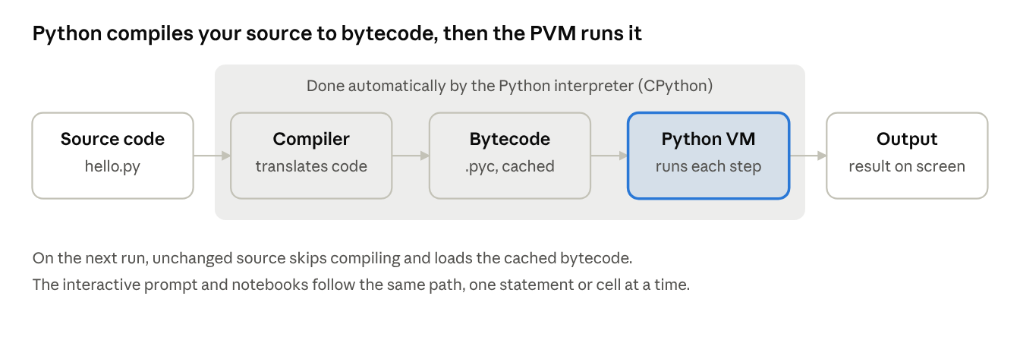
execution model · 5 stages
Read the diagram left to right: only the three boxes inside the shaded band are done by Python for you.

1.4 Your first program
# hello.py
name = "Data Science"
print("Hello,", name)
Run it from a terminal with python hello.py. You can also type statements one at a time at the interactive prompt (>>>), which is ideal for quick experiments.

1.5 Basic syntax rules
- Indentation defines blocks. There are no braces; use 4 spaces consistently.
- A colon (:) opens a block after if, for, while, def, class and try.
- Comments start with #; a string at the top of a function is its docstring.
- Names are case-sensitive: Data and data are different variables.
- Identifiers may contain letters, digits and underscores, cannot start with a digit and cannot be keywords such as if or class.

2. Types and Operations
In Python everything is an object, and every object has a type that decides what operations it supports; the built-in types below hold almost all the data you will analyse.

2.1 Core built-in types at a glance
Type | Example | Mutable? | Ordered? | Typical use
int | 42 | No | n/a | Counts, IDs
float | 3.14 | No | n/a | Measurements
complex | 2 + 3j | No | n/a | Signal processing
bool | True | No | n/a | Conditions, masks
str | 'data' | No | Yes | Text, labels
list | [1, 2, 3] | Yes | Yes | Growing collections
tuple | (1, 2) | No | Yes | Fixed records
dict | {'a': 1} | Yes | Insertion order | Lookup by key
set | {1, 2} | Yes | No | Unique values
A mutable object can be changed in place; an immutable one can only be replaced by a new object.

2.2 Numbers and numeric types
Python has three built-in numeric types: int (whole numbers of unlimited size), float (double-precision decimals) and complex (real and imaginary parts). bool is a subtype of int, where True == 1 and False == 0. The standard library adds Decimal (exact decimal arithmetic) and Fraction (exact rational numbers).
Operator | Meaning | Example | Result
+ | Addition | 7 + 2 | 9
- | Subtraction | 7 - 2 | 5
* | Multiplication | 7 * 2 | 14
/ | True division | 7 / 2 | 3.5
// | Floor division | 7 // 2 | 3
% | Remainder | 7 % 2 | 1
** | Power | 7 ** 2 | 49
print(2 ** 100) # 1267650600228229401496703205376 (no overflow)
print(0.1 + 0.2) # 0.30000000000000004 (binary floating point)
print(round(0.1 + 0.2, 2)) # 0.3
print(divmod(17, 5)) # (3, 2) -> quotient and remainder
print(int("25") + float("1.5")) # 26.5 -> conversion functions
When types are mixed, Python converts to the "wider" type (int to float to complex). Floats cannot represent every decimal exactly, so compare them with a tolerance (math.isclose) rather than ==. Useful built-ins are abs(), round(), pow() and divmod(); the math module adds sqrt, log, sin and constants such as math.pi.

2.3 Strings
A string is an immutable sequence of characters written in single, double or triple quotes. Because it is a sequence, it supports indexing, slicing, iteration and the in operator.
s = "Data Science"
print(s[0]) # 'D' first character
print(s[-1]) # 'e' last character
print(s[0:4]) # 'Data' slice: start included, stop excluded
print(s[::-1]) # 'ecneicS ataD' reversed
print(len(s)) # 12
print("Sci" in s) # True
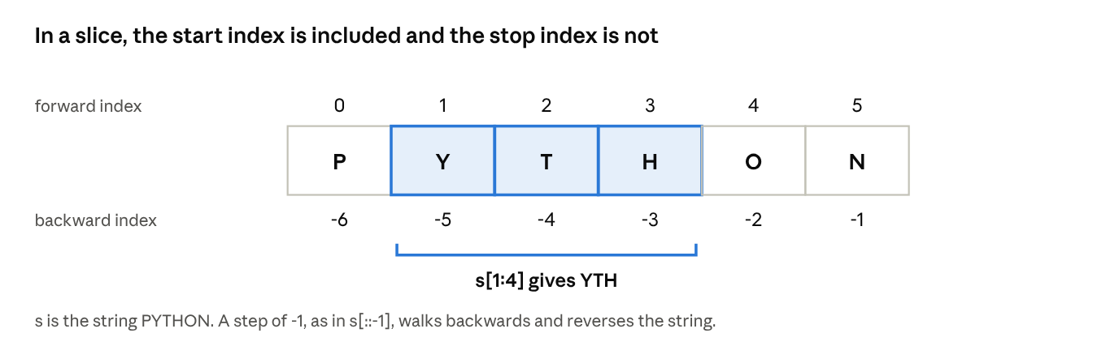
string indexing and slicing · PYTHON
Every character has two indexes, one counted from the front and one from the back; the same rules apply to lists and tuples.
Method | What it does | Example
upper() / lower() | Change case | 'ab'.upper() gives 'AB'
strip() | Remove edge whitespace | ' x '.strip() gives 'x'
split(sep) | Break into a list | 'a,b'.split(',') gives ['a','b']
join(list) | Glue a list together | '-'.join(['a','b']) gives 'a-b'
replace(old, new) | Substitute text | 'cat'.replace('c','b') gives 'bat'
find(sub) | Index of first match, or -1 | 'data'.find('t') gives 2
Formatting inserts values into text. The modern way is the f-string: f"Mean = {mean:.2f}". Older forms are "{}".format(x) and "%d" % x. Escape sequences such as \n (newline) and \t (tab) work in normal strings; prefix with r for a raw string (r"C:\new") when backslashes should stay literal.

2.4 Lists
A list is an ordered, mutable collection that can hold objects of any type, including other lists. It is Python's workhorse for holding a column or a batch of records.
marks = [72, 85, 91]
marks.append(66) # [72, 85, 91, 66]
marks.insert(1, 80) # [72, 80, 85, 91, 66]
marks.remove(91) # [72, 80, 85, 66]
last = marks.pop() # removes and returns 66
marks.sort(reverse=True) # [85, 80, 72]
print(marks[0:2]) # [85, 80]
matrix = [[1, 2], [3, 4]] # nested list
print(matrix[1][0]) # 3
Method | Purpose
append(x) | Add one item at the end
extend(iterable) | Add every item of another sequence
insert(i, x) | Insert before index i
remove(x) | Delete the first occurrence of x
pop(i) | Remove and return item at i (default last)
sort() / reverse() | Reorder in place
index(x) / count(x) | Position of x / how many times it occurs
Aliasing warning: b = a does not copy a list; both names point to the same object. Use b = a.copy() or b = a[:] for a shallow copy, and copy.deepcopy(a) for nested data.

2.5 Tuples
A tuple is an ordered, immutable sequence written with parentheses. Use it for a fixed record, such as a coordinate or a row you must not modify, and as a dictionary key (tuples are hashable, lists are not).
point = (3, 4)
x, y = point # unpacking -> x = 3, y = 4
single = (5,) # the comma makes it a tuple; (5) is just an int
print(point + (5,)) # (3, 4, 5) -> builds a new tuple
point[0] = 9 # TypeError: tuples do not support item assignment
Functions that "return several values" actually return one tuple, which the caller unpacks.

2.6 Dictionaries
A dictionary stores key: value pairs and finds a value by its key in near-constant time. Keys must be unique and immutable (strings, numbers, tuples); values can be anything. Since Python 3.7 a dictionary remembers insertion order.
student = {"name": "Asha", "age": 20, "marks": [72, 85]}
print(student["name"]) # 'Asha'
print(student.get("city", "NA")) # 'NA' -> safe lookup with default
student["age"] = 21 # update
student["city"] = "Kochi" # add
del student["marks"] # delete
for key, value in student.items():
print(key, "->", value)
Method | Purpose
keys() / values() / items() | Views of keys, values, or (key, value) pairs
get(k, default) | Lookup that never raises KeyError
update(other) | Merge another dictionary in
pop(k) | Remove a key and return its value
setdefault(k, v) | Insert k with v only if it is missing
Dictionaries mirror JSON records and become the rows and columns of a pandas DataFrame later in the course.

2.7 Files
The built-in open() returns a file object connected to a file on disk. Always use the with statement, which closes the file automatically even if an error occurs.
Mode | Meaning
'r' | Read text (default); error if the file is missing
'w' | Write text; creates the file or erases an existing one
'a' | Append to the end of the file
'r+' | Read and write
'b' | Add to any mode for binary data, such as 'rb' or 'wb'
with open("scores.txt", "w") as f:
f.write("Asha,72\n")
f.write("Ravi,85\n")
with open("scores.txt") as f:
for line in f: # a file is iterable, line by line
name, mark = line.strip().split(",")
print(name, int(mark))
The main read methods are read() (whole file as one string), readline() (next line) and readlines() (list of all lines). Iterating over the file object is the most memory-friendly choice for big files.

2.8 Dynamic typing
In Python a variable is only a name that refers to an object. The type lives in the object, not in the name, so the same name can refer to an int now and a string later. Assignment never copies data; it just points the name at an object.
x = 10 # x refers to an int object
x = "ten" # x now refers to a str object; the int is discarded
a = [1, 2]
b = a # both names refer to the same list
b.append(3)
print(a) # [1, 2, 3] -> change is visible through both names
print(a is b) # True -> same object
print(a == [1, 2, 3]) # True -> equal values
print(type(a), isinstance(a, list))
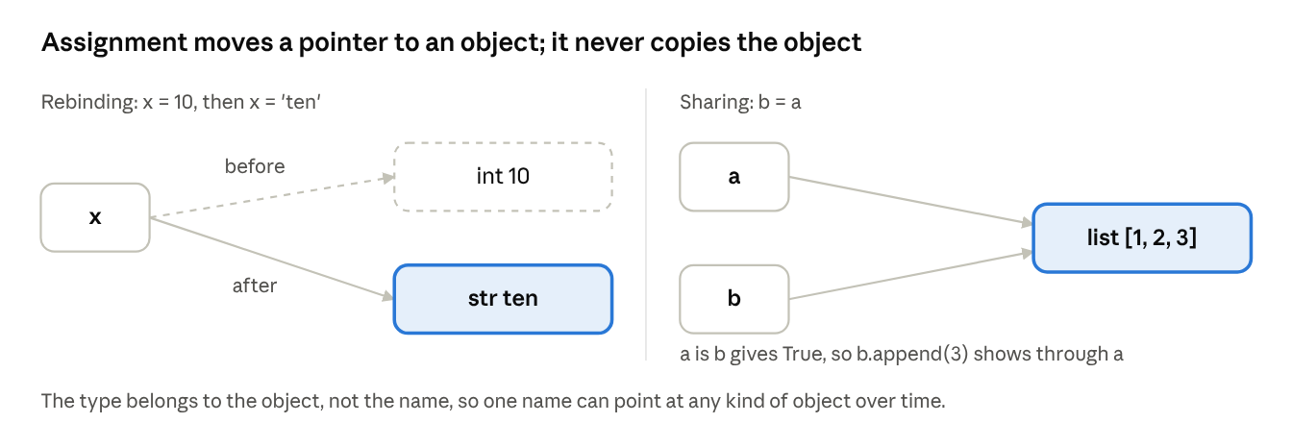
names and objects · rebinding and sharing
The dashed arrow shows the old link that is dropped when a name is rebound; once nothing points to the int, Python frees it.
- Reference counting: each object tracks how many names point to it; at zero it is freed by garbage collection.
- is versus ==: is asks whether two names refer to the same object; == asks whether the values are equal.
- Consequence: shared references to mutable objects can cause surprising side effects, while immutable objects (numbers, strings, tuples) are safe to share.
- Type checking happens at run time: "a" + 1 raises TypeError only when that line runs.

3. Statements and Syntax
A Python program is a sequence of statements; assignments store results, expressions compute values, and compound statements (conditions and loops) control which statements run and how often.

3.1 Syntax rules for statements
- One statement per line is the norm; a line ends the statement.
- To continue a long statement, wrap it in brackets ( ), [ ], { } or end the line with a backslash \.
- Compound statements (if, for, while, def, class, try, with) end their header with a colon and indent the block beneath.
- All lines in one block must share the same indentation; a smaller indent ends the block.
total = (10 + 20 +
30 + 40) # brackets allow a statement to span lines
if total > 50:
print("large") # indented -> belongs to the if block
print("done") # not indented -> always runs

3.2 Assignments
An assignment binds a name to an object. Python offers several assignment forms.
Form | Example | Effect
Basic | x = 5 | Bind x to 5
Chained | a = b = 0 | Both names refer to the same object
Tuple unpacking | a, b = 1, 2 | Match values to names by position
Swap | a, b = b, a | Exchange values without a temporary
Starred | first, *rest = [1, 2, 3, 4] | rest becomes [2, 3, 4]
Augmented | count += 1 | Shorthand for count = count + 1

3.3 Expressions
An expression produces a value (3 * 4, len(s), x > 2); a statement performs an action (x = 3, print(x)). An expression on its own line, such as a function call, is an expression statement.
- Precedence (high to low): **, unary -, * / // %, + -, comparisons, not, and, or. Use brackets when in doubt.
- Comparison chaining: 0 < x < 10 works as in mathematics.
- Short-circuit logic: in a and b, b is evaluated only if a is true; in a or b, only if a is false.
- Conditional expression: label = "pass" if mark >= 40 else "fail".

3.4 Conditional statements
mark = 72
if mark >= 75:
grade = "A"
elif mark >= 60:
grade = "B"
else:
grade = "C"
print(grade) # B
Python tests conditions in order and runs the first block whose test is true. Values such as 0, "", [], {} and None count as false; everything else is true.

3.5 Loops
A loop repeats a block. Use for when you know what to iterate over and while when you repeat until a condition changes.
for i in range(1, 6): # 1, 2, 3, 4, 5
if i == 4:
continue # skip the rest of this pass
print(i)
n = 3
while n > 0:
print(n)
n -= 1 # without this the loop never ends
for x in [2, 4, 6]:
if x == 5:
break # leave the loop immediately
else:
print("no break occurred") # runs only if the loop was not broken
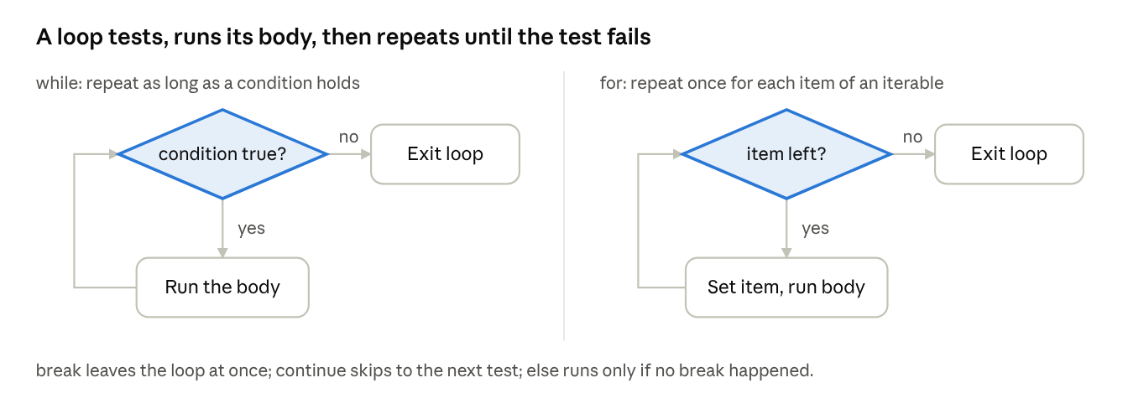
while and for loop flow · 2 flowcharts
Both loops share the same cycle; the difference is what is tested, a condition for while and the supply of items for for.
Statement | Role
break | Exit the nearest loop immediately
continue | Jump to the next iteration
pass | Do nothing; a placeholder for an empty block
else on a loop | Runs when the loop finishes without break
range(start, stop, step) | Sequence of integers; stop is excluded

3.6 Iterations
An iterable is any object a for loop can walk through (list, string, dictionary, file, range). When a loop starts, Python calls iter() to get an iterator, then calls next() repeatedly until the iterator raises StopIteration.
it = iter([10, 20])
print(next(it)) # 10
print(next(it)) # 20
# next(it) would now raise StopIteration
names = ["Asha", "Ravi"]
marks = [72, 85]
for i, name in enumerate(names, start=1): # index + value
print(i, name)
for name, mark in zip(names, marks): # walk two lists together
print(name, mark)
Iterators are lazy: they produce one item at a time, which lets you process files far bigger than memory. Other helpers are reversed(), sorted(), sum(), min(), max(), any() and all().

3.7 Comprehensions
A comprehension builds a new collection from an iterable in a single readable expression. It replaces a loop that appends to a list.
squares = [n * n for n in range(1, 6)] # [1, 4, 9, 16, 25]
evens = [n for n in range(10) if n % 2 == 0] # filter
lookup = {name: len(name) for name in ["Asha", "Ravi"]} # dict comprehension
unique = {m // 10 * 10 for m in [72, 75, 81]} # set comprehension
total = sum(n * n for n in range(1000)) # generator expression
Kind | Brackets | Result
List comprehension | [ ... ] | A list built immediately
Dict comprehension | {k: v ...} | A dictionary
Set comprehension | { ... } | A set of unique items
Generator expression | ( ... ) | A lazy iterator; computes items on demand
The general pattern is [expression for item in iterable if condition]. Keep comprehensions short; switch to a normal loop when the logic needs several steps.

4. Functions
A function is a named, reusable block of code that takes inputs, does work and returns a result; it is the main tool for avoiding repetition and structuring an analysis.

4.1 Function basics
A function is created with def, called with parentheses, and hands a value back with return. A function without return gives back None. The first string in the body is the docstring, which documents the function.
def mean(values):
"""Return the average of a list of numbers."""
return sum(values) / len(values)
print(mean([72, 85, 91])) # 82.66666666666667
def min_max(values):
return min(values), max(values) # returns one tuple
low, high = min_max([4, 9, 2]) # unpacked by the caller
def is an executable statement: it creates a function object and binds it to a name at run time. Because Python does not check types in advance, mean works on a list, a tuple or any iterable of numbers (this is polymorphism).

4.2 Scopes
A scope is the region of a program where a name is visible. Python looks a name up in this order, known as LEGB:
- Local: names assigned inside the current function.
- Enclosing: names in any outer function around the current one.
- Global: names at the top level of the module (file).
- Built-in: names Python supplies, such as len, print and range.
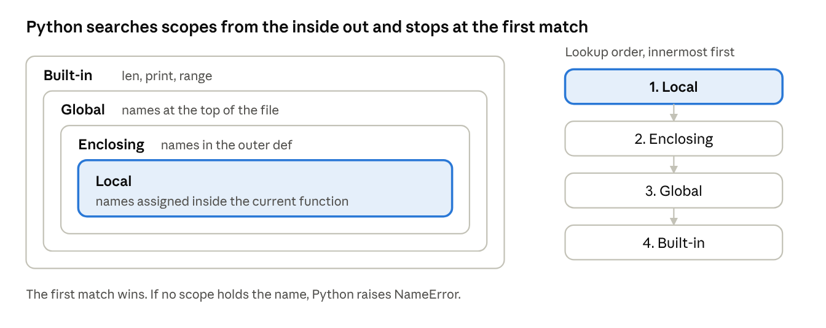
LEGB scope rule · 4 nested scopes
The nested boxes show where each scope lives; the numbered list on the right is the order in which Python checks them.
x = "global"
def outer():
x = "enclosing"
def inner():
x = "local"
print(x) # local
inner()
print(x) # enclosing
outer()
print(x) # global
count = 0
def bump():
global count # allow assignment to the module-level name
count += 1
def counter():
n = 0
def step():
nonlocal n # allow assignment to the enclosing name
n += 1
return n
return step
Assigning to a name inside a function makes it local by default. Use global or nonlocal only when you really must change an outer variable; returning values is cleaner.

4.3 Arguments
Arguments are passed by assignment: the parameter name is bound to the same object the caller passed. Mutating a list inside a function therefore changes the caller's list, while rebinding the name does not.
Kind | Syntax | Example call
Positional | def f(a, b) | f(1, 2)
Keyword | def f(a, b) | f(b=2, a=1)
Default | def f(a, b=10) | f(1) uses b = 10
Variable positional | def f(*args) | f(1, 2, 3) gives the tuple (1, 2, 3)
Variable keyword | def f(**kwargs) | f(x=1, y=2) gives the dict {'x': 1, 'y': 2}
Keyword-only | def f(a, *, b) | f(1, b=2)
Unpacking at call | f(*list, **dict) | f(*[1, 2]), f(**{'a': 1})
def describe(name, age=18, *hobbies, **extra):
print(name, age, hobbies, extra)
describe("Asha", 20, "chess", "music", city="Kochi")
# Asha 20 ('chess', 'music') {'city': 'Kochi'}
def add_item(item, bucket=[]): # trap: the default list is created once
bucket.append(item)
return bucket
def add_item_safe(item, bucket=None): # correct pattern
if bucket is None:
bucket = []
bucket.append(item)
return bucket
Rule: never use a mutable object (list, dictionary) as a default value, because it is shared by every call.

4.4 Advanced functions
Functions are first-class objects: they can be stored in variables, put in lists and passed to or returned from other functions.
- lambda: a small anonymous function written as one expression: square = lambda x: x * x.
- map, filter, reduce: apply a function across data. list(map(len, ["ab", "cde"])) gives [2, 3]; list(filter(lambda n: n > 2, [1, 3, 5])) gives [3, 5]; functools.reduce folds a sequence into one value.
- Recursion: a function that calls itself, needing a base case to stop.
- Closures: an inner function that remembers variables of the enclosing function (the counter example above).
- Generators: a function using yield produces values lazily, one per request, and keeps its state between requests.
- Decorators: a function that wraps another function to add behaviour without editing it.
- Annotations: optional hints such as def f(x: int) -> float: that document intent; Python does not enforce them.
def factorial(n):
return 1 if n <= 1 else n * factorial(n - 1) # recursion
def countdown(n):
while n > 0:
yield n # generator: pauses here, resumes on next()
n -= 1
print(list(countdown(3))) # [3, 2, 1]
import time
def timer(func): # a decorator
def wrapper(*args, **kwargs):
start = time.time()
result = func(*args, **kwargs)
print(func.__name__, "took", time.time() - start, "seconds")
return result
return wrapper
@timer # same as: slow_sum = timer(slow_sum)
def slow_sum(n):
return sum(range(n))

5. Modules
A module is simply a Python file whose names (functions, classes, variables) can be reused in other files; modules and packages are how Python code, including NumPy and pandas, is organised and shared.

5.1 Module coding basics
Any file ending in .py is a module. Importing it runs the file once and gives you a module object whose attributes are the names defined inside it.
# stats_tools.py (the module)
PI = 3.14159
def mean(values):
return sum(values) / len(values)
def variance(values):
m = mean(values)
return sum((v - m) ** 2 for v in values) / len(values)

# analysis.py (uses the module)
import stats_tools # use as stats_tools.mean(...)
import stats_tools as st # alias: st.mean(...)
from stats_tools import mean, variance # bring names in directly
from stats_tools import * # everything public; avoid in real code
print(st.mean([2, 4, 6])) # 4.0
Form | Names you type afterwards | Advice
import m | m.name | Clear and safe; the default choice
import m as x | x.name | Standard for long names, such as import numpy as np
from m import a, b | a, b | Good for a few frequently used names
from m import * | all public names | Risky: can silently overwrite your own names
When Python meets import m it performs three steps: find the file, compile it to bytecode if needed, and run it to build the module object. The module is then stored in sys.modules, so a second import m reuses it instead of running the file again.
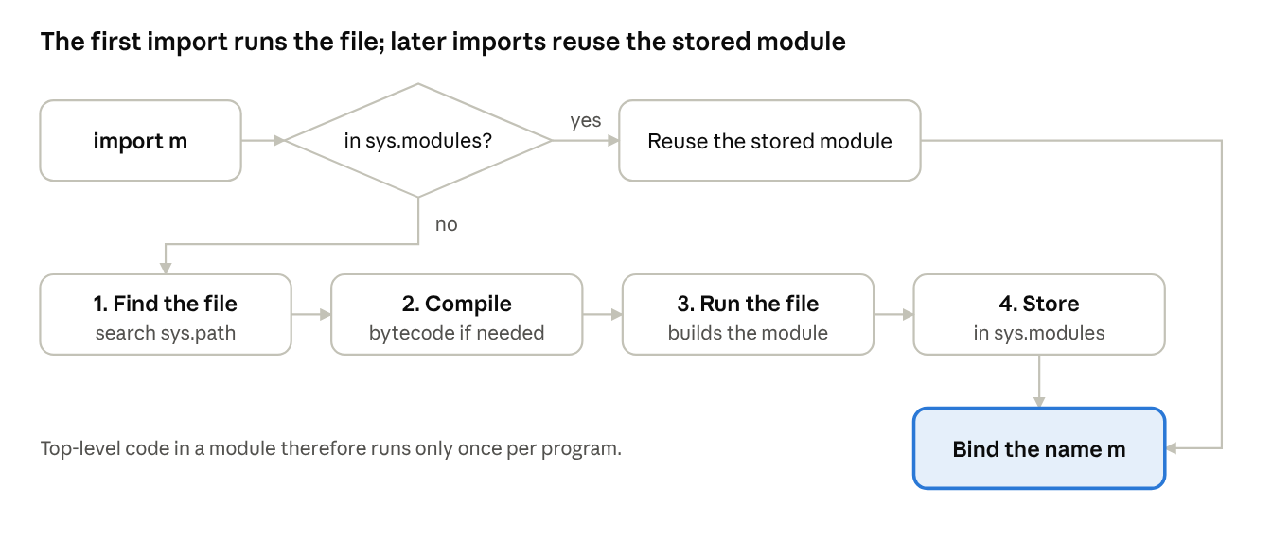
import process · 1 decision, 4 steps
The decision at the top is the module cache: a module already in sys.modules skips the four steps entirely.
Python searches for modules in this order, listed in sys.path: the folder of the running script, any folders in the PYTHONPATH environment variable, the standard library, and installed third-party packages in site-packages.

5.2 Module packages
A package is a folder of modules, imported with dotted names. A folder containing an __init__.py file is a regular package; the file runs on import and can expose a friendlier interface.
shop/ <- package
__init__.py
inventory.py <- module
billing/ <- sub-package
__init__.py
tax.py
invoice.py

import shop.inventory
from shop.billing import tax
from shop.billing.invoice import make_invoice
# inside shop/billing/invoice.py, a relative import of a sibling module:
from . import tax # . = this package
from .. import inventory # .. = parent package
Third-party packages are installed with pip install pandas and then imported like any other package. This is exactly how import numpy as np and import pandas as pd work.

5.3 Advanced module topics
- __name__ and the main guard. When a file is run directly its __name__ is "__main__"; when imported it is the module's name. Code under if __name__ == "__main__": therefore runs only when the file is executed, not when imported, so one file can serve as both a library and a script.
- Data hiding. A name starting with an underscore (_helper) signals "internal". Defining __all__ = ["mean", "variance"] controls exactly which names from m import * exports.
- Modules are objects. dir(module) lists their names, module.__file__ gives the file location, and module.__doc__ gives the docstring.
- Reloading and dynamic import. importlib.reload(m) re-runs an already imported module (useful in notebooks), and importlib.import_module("name") imports using a name held in a string.
- Circular imports. If module A imports B while B imports A, one of them may be only partly built. Fix it by moving shared code to a third module or by importing inside a function.
- Namespaces. Each module has its own global namespace, so a variable named x in two modules never clashes.
# stats_tools.py
def mean(values):
return sum(values) / len(values)
if __name__ == "__main__": # runs only for: python stats_tools.py
print("self-test:", mean([1, 2, 3]))

6. Classes and OOP
A class is a blueprint that bundles data (attributes) and behaviour (methods) into one unit; every list, dictionary, NumPy array and pandas DataFrame you use is an instance of a class.

6.1 Class basics
A class defines a new type. Calling the class creates an instance (an object). Each instance has its own attributes, while methods are shared by all instances.
class Student:
school = "JNTUGV" # class attribute: shared by all instances
def __init__(self, name, marks): # constructor: runs when an object is created
self.name = name # instance attributes: unique to each object
self.marks = marks
def average(self): # method: first parameter is always self
return sum(self.marks) / len(self.marks)
def __str__(self): # text shown by print()
return f"{self.name}: {self.average():.1f}"
s1 = Student("Asha", [72, 85, 91])
print(s1) # Asha: 82.7
print(s1.average()) # 82.666...
print(Student.school) # JNTUGV
- self refers to the instance on which the method was called.
- __init__ is the initializer that sets up a new object's attributes.
- Class attribute versus instance attribute: a class attribute is shared; self.x = ... creates one attribute per object.
Inheritance lets a new class reuse and extend an existing one. The new class is the subclass (child), the existing one the superclass (parent).
class GradStudent(Student): # GradStudent is-a Student
def __init__(self, name, marks, thesis):
super().__init__(name, marks) # reuse the parent's setup
self.thesis = thesis
def __str__(self): # override the parent's method
return f"{super().__str__()} | thesis: {self.thesis}"
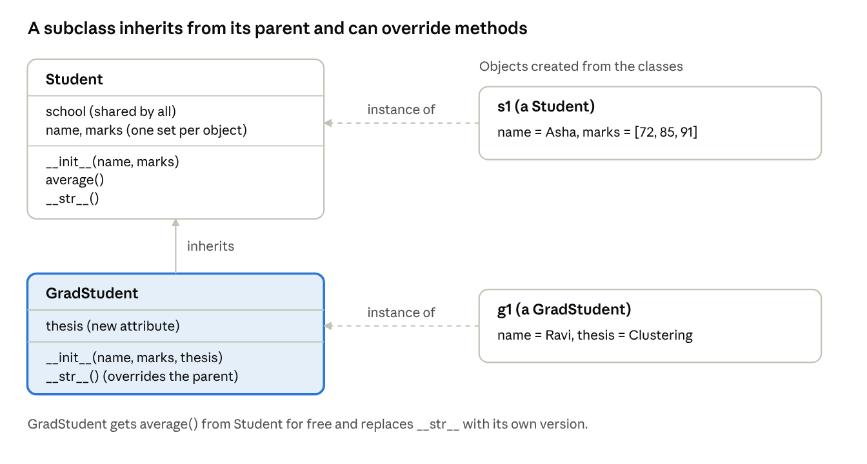
class inheritance · 2 classes, 2 objects
Solid arrows join classes and dashed arrows join an object to its class; method lookup starts at the object's own class and then climbs to the parent.
The four pillars of object-oriented programming are listed below.
Pillar | Meaning | Python example
Encapsulation | Bundle data with the methods that use it, and hide internals | _balance, __secret naming
Inheritance | Reuse and extend a class | class Child(Parent)
Polymorphism | Same call, different behaviour per class | len(x) works on lists, strings, dicts
Abstraction | Expose a simple interface, hide the detail | A fit() method that hides the algorithm

6.2 Operator overloading
Operators such as +, ==, [] and len() call special methods whose names begin and end with double underscores ("dunder" methods). By defining them, your own class can work with Python's operators.
Expression | Method called | Purpose
a + b | __add__ | Addition
a - b | __sub__ | Subtraction
a * b | __mul__ | Multiplication
a == b | __eq__ | Equality
a < b | __lt__ | Ordering and sorting
len(a) | __len__ | Length
a[i] | __getitem__ | Indexing and slicing
x in a | __contains__ | Membership test
for x in a | __iter__ | Iteration
a(args) | __call__ | Make an object callable
print(a) | __str__ | Readable text
repr(a) | __repr__ | Unambiguous text for debugging
class Vector:
def __init__(self, x, y):
self.x, self.y = x, y
def __add__(self, other): # v1 + v2
return Vector(self.x + other.x, self.y + other.y)
def __mul__(self, k): # v * 3
return Vector(self.x * k, self.y * k)
def __eq__(self, other): # v1 == v2
return (self.x, self.y) == (other.x, other.y)
def __len__(self): # len(v)
return 2
def __repr__(self):
return f"Vector({self.x}, {self.y})"
v = Vector(1, 2) + Vector(3, 4)
print(v) # Vector(4, 6)
print(v * 2) # Vector(8, 12)
This is exactly why array1 + array2 in NumPy adds element by element and df["col"] in pandas selects a column: those classes overload the operators.

6.3 Class designing
Good class design decides what each class is responsible for and how classes relate to one another.
- Is-a versus has-a. Use inheritance when the child is a kind of the parent (a GradStudent is a Student). Use composition when one object contains another (a Report has a Dataset). Prefer composition when unsure; it is more flexible.
- Single responsibility. One class, one job. A class that loads, cleans, plots and emails data should be split into four.
- Encapsulation by convention. A leading underscore (_x) means "internal"; a double underscore (__x) triggers name mangling. Use @property to expose a controlled attribute.
- Polymorphism and duck typing. If an object has the method you call, it works, whatever its class. Code against behaviour, not type.
- Method kinds. An instance method uses self; a @classmethod uses cls and often builds alternative constructors; a @staticmethod is a plain function placed inside the class.
- Multiple inheritance. A class may have several parents; Python resolves the lookup order with the method resolution order (MRO), visible as ClassName.__mro__.
class Dataset:
def __init__(self, rows):
self._rows = rows
@property
def size(self): # read-only computed attribute
return len(self._rows)
@classmethod
def from_csv(cls, path): # alternative constructor
with open(path) as f:
return cls([line.strip().split(",") for line in f])
class Cleaner:
def drop_empty(self, rows):
return [r for r in rows if all(r)]
class Pipeline: # composition: a Pipeline HAS a Dataset and a Cleaner
def __init__(self, data):
self.data = data
self.cleaner = Cleaner()
def run(self):
return self.cleaner.drop_empty(self.data._rows)

7. Exceptions and Tools
An exception is an event that interrupts normal execution when something goes wrong; handling exceptions lets a data-processing script recover from bad input instead of crashing, and system tools let it use the whole machine.

7.1 Exception basics
Python stops at the failing line and looks for a handler. If none exists, the default handler prints a traceback (the chain of calls that led to the error) and ends the program. A try statement lets you catch the error and carry on.
try:
value = int(input("Enter a number: "))
print(10 / value)
except ValueError:
print("That was not a number")
except ZeroDivisionError:
print("Cannot divide by zero")
Exception | Typical cause
SyntaxError | Invalid code; found before the program runs
NameError | Using a variable that was never defined
TypeError | Wrong type for an operation, such as "a" + 1
ValueError | Right type, unsuitable value, such as int("abc")
IndexError | List index out of range
KeyError | Missing dictionary key
ZeroDivisionError | Division or modulo by zero
FileNotFoundError | Opening a file that does not exist
AttributeError | Object has no such attribute or method
ImportError | A module or name cannot be imported

7.2 Exception coding details
The full try statement has four parts, and each plays a distinct role.
Clause | Runs when | Use it for
try | Always first | The risky code
except | The try block raised a matching exception | Recovery or a clear message
else | The try block raised no exception | Code that should run only on success
finally | Always, error or not | Cleanup such as closing a file
↗ try statement flow · 2 decisions, 3 outcomes
Follow the three lanes from top to bottom: no error, an error that is caught, and an error that is not; all three end in the finally block.
def read_scores(path):
try:
f = open(path)
except FileNotFoundError as err:
print("Missing file:", err)
return []
except (PermissionError, IsADirectoryError): # several types in a tuple
print("Cannot read this path")
return []
else:
scores = [int(line) for line in f] # only if open() worked
return scores
finally:
print("read_scores finished") # runs in every case
- raise triggers an exception yourself: raise ValueError("age must be positive"). A bare raise inside an except block re-raises the current error.
- raise NewError from err chains a new exception to the original cause.
- assert checks an assumption while debugging: assert len(rows) > 0, "no data" raises AssertionError when the test is false.
- with uses a context manager for guaranteed cleanup, which is why with open(...) is preferred to a manual try/finally.
- Propagation: an uncaught exception travels up through the calling functions until a matching handler is found or the program stops.

7.3 Exception objects
Exceptions are instances of classes arranged in an inheritance tree. Every built-in exception descends from BaseException; ordinary errors descend from Exception. An except clause catches the named class and all its subclasses, so except LookupError catches both IndexError and KeyError.
↗ exception class hierarchy · 14 classes
Read the tree left to right: except LookupError would catch IndexError and KeyError, while except Exception catches everything in the highlighted branch.
try:
{}["missing"]
except KeyError as e: # e is the exception object
print(type(e).__name__) # KeyError
print(e.args) # ('missing',)
print(e) # 'missing'
You can define your own exception by subclassing Exception. Custom classes can carry extra data about the failure.
class InvalidRecordError(Exception):
def __init__(self, row_number, message):
super().__init__(f"Row {row_number}: {message}")
self.row_number = row_number
def check(row, n):
if row.get("age", 0) <= 0:
raise InvalidRecordError(n, "age must be positive")
try:
check({"age": -3}, 7)
except InvalidRecordError as e:
print(e, "| bad row:", e.row_number) # Row 7: age must be positive | bad row: 7

7.4 Designing with exceptions
- Catch specific exceptions. Avoid a bare except: or a blanket except Exception:; they hide real bugs such as typos.
- Handle an error where you can fix it. Let the exception travel up to the layer that knows what to do (retry, skip the row, show a message).
- Keep try blocks small, wrapping only the line that can fail, so you know which statement raised.
- EAFP over LBYL. "Easier to ask forgiveness than permission" (try it and catch the error) is the Python style; "look before you leap" checks conditions first and can be slower or racy.
- Always release resources with finally or with.
- Use custom exceptions to express problems in your domain, and group them under one base class so callers can catch them together.
- Do not use exceptions for ordinary control flow when a simple if is clearer. The exception is StopIteration, which Python itself uses to end loops.
- Log, do not hide. Record the traceback with the logging module so failures can be diagnosed later.
import logging
def load_rows(path):
good, bad = [], []
with open(path) as f:
for n, line in enumerate(f, start=1):
try:
good.append(float(line))
except ValueError: # specific, small, recoverable
bad.append(n)
logging.warning("Skipped bad row %d", n)
return good, bad

7.5 Parallel system tools
Data jobs are often slow because they wait for disks and networks (I/O-bound) or because they crunch numbers (CPU-bound). Python's system tools let you talk to the operating system and run work in parallel.
System interfaces. The sys module exposes the interpreter (sys.argv for command-line arguments, sys.path, sys.exit()); the os module exposes the operating system (os.getcwd(), os.listdir(), os.environ, os.cpu_count()); and subprocess launches other programs and captures their output.
Parallel tools.
Tool | Module | Best for | Notes
Threads | threading, concurrent.futures.ThreadPoolExecutor | I/O-bound work (downloads, file reads) | Share memory; in the standard build the Global Interpreter Lock (GIL) lets only one thread run Python bytecode at a time
Processes | multiprocessing, concurrent.futures.ProcessPoolExecutor | CPU-bound work (heavy calculation) | Separate memory and interpreter per process, so they use several cores
Asynchronous I/O | asyncio | Thousands of waiting network tasks | One thread, cooperative async and await
Recent Python releases (3.13 onward) add an optional free-threaded build without the GIL, but the standard build still has it. For CPU-bound data work, the usual choices are multiple processes or libraries such as NumPy that run their inner loops in compiled code.
from concurrent.futures import ProcessPoolExecutor
import os
def heavy(n):
return sum(i * i for i in range(n))
if __name__ == "__main__": # required for multiprocessing on Windows/macOS
jobs = [10_000_000] * os.cpu_count()
with ProcessPoolExecutor() as pool: # one worker process per core by default
results = list(pool.map(heavy, jobs)) # runs the jobs in parallel
print(len(results), "jobs finished")

Quick revision
If you remember only one idea per topic, remember the ones in this table.
Topic | One idea to remember
Introducing Python | Source code is compiled to bytecode, then run by the Python Virtual Machine; indentation defines blocks
Numbers | int, float, complex; / gives a float, // floors, ** is a power
Strings | Immutable sequences; slice with s[start:stop:step], with stop excluded
Lists | Mutable and ordered; b = a shares one object, a.copy() makes a new one
Tuples | Immutable; used for fixed records, unpacking and dictionary keys
Dictionaries | Key-to-value lookup; keys must be immutable and unique
Files | Use with open(...); modes r, w, a, plus b for binary
Dynamic typing | Names refer to objects; the type belongs to the object; is compares identity, == compares value
Statements | Assignment binds names; if/elif/else branches; for and while repeat
Iterations | Iterable gives an iterator through iter(); next() ends with StopIteration
Comprehensions | [expr for x in it if cond] builds a collection in one line
Functions | def, return, docstring; arguments are passed by object reference
Scopes | Lookup order is Local, Enclosing, Global, Built-in (LEGB)
Arguments | Positional, keyword, default, *args, **kwargs; never use a mutable default
Advanced functions | Lambda, map, filter, closures, generators (yield), decorators (@)
Modules | A .py file; import finds, compiles and runs it once, then caches it in sys.modules
Packages | A folder with __init__.py; imported with dotted names
Classes | __init__ sets up the object; self is the instance; subclasses override methods
Operator overloading | a + b calls a.__add__(b); len(a) calls a.__len__()
Exceptions | try, except, else, finally; catch specific types; raise to signal errors
Parallel tools | Threads for I/O waits, processes for CPU work, because of the GIL

Likely exam questions
Short answer (2 to 3 marks)
- List any four features of Python.
- Differentiate between a list and a tuple.
- What is dynamic typing? Give an example.
- Write the output of [x * x for x in range(4)].
- State the LEGB rule.
- What is the purpose of if __name__ == "__main__":?
- Differentiate between is and ==.
- What is the role of the finally clause?
Long answer (5 to 10 marks)
- Explain how a Python program is executed, with a diagram.
- Describe the core built-in data types of Python with examples of their operations.
- Explain the different types of function arguments with examples.
- Explain how modules and packages are created and imported.
- Explain classes, inheritance and operator overloading with a program.
- Explain exception handling in Python, covering try, except, else, finally and user-defined exceptions.
- Compare threads, processes and asynchronous I/O for parallel programming in Python.

References
The first two lists are the books prescribed in the syllabus; the third lists the official Python documentation that matches each part of this unit.

Text books
- Mark Lutz, Learning Python, O'Reilly.
- Mark Lutz, Programming Python, O'Reilly.
- Wes McKinney, Python for Data Analysis, O'Reilly.

Reference books
- Martin C. Brown, Python: The Complete Reference, McGraw Hill Education.
- Paul Barry, Head First Python, O'Reilly.

